Structured programming -lab
Course code: cse 1384
Assignment project
Title: Emergency Potable Water Allocation for a Flood-Affected Municipality

Submitted to:

Abdullah Mohammad sakib
lecturer
Department of computer science and technology

Submitted by:

Tawhidul islam
Id:26103042
Program: BCSE
Section: D
Serial :9
Submission date: 6-9-2026



IUBAT- international university of business agricultural and technology

1. Problem Analysis
The dataset supplied for the purpose of this assignment, describing the six service zones and the 13,500 liters of potable water available for distribution among them, is reproduced below.
Zone ID | Service Zone | Type | Requested Water (L) | Minimum Requirement (L) | Distribution Loss (%) | Previous Waiting Cycles
Z01 | Municipal Hospital | Hospital | 4,000 | 3,000 | 2 | 0
Z02 | Central Flood Shelter | Emergency Shelter | 3,500 | 2,500 | 4 | 1
Z03 | Ward 3 Residential Area | Residential | 4,500 | 2,000 | 8 | 2
Z04 | Ward 5 Residential Area | Residential | 3,800 | 1,800 | 12 | 3
Z05 | School Emergency Shelter | Emergency Shelter | 2,600 | 1,600 | 5 | 1
Z06 | Fire and Emergency Service | Emergency Service | 2,000 | 1,500 | 1 | 0

1.1 Nature of the Problem
A flood-affected municipality operating a temporary water-distribution center faces a situation in which the total quantity of potable water requested by its service zones exceeds the quantity actually available for distribution. Because the shortfall cannot be resolved within a single distribution cycle, the center must decide, in a defensible and repeatable manner, how the available water is divided among hospitals, emergency shelters, residential areas and emergency services, each of which differs in the urgency of its need, the length of time it has already waited for supply, and the proportion of released water it is able to actually receive once distribution loss is accounted for.

1.2 Major Factors Affecting the Allocation Decision
- Requested quantity — the volume each zone has asked to receive in the current cycle, representing its stated demand.
- Minimum requirement — the smallest quantity considered adequate for the zone to continue functioning without serious harm; falling below this figure is a materially different outcome from merely receiving less than requested.
- Nature of the service zone — whether the zone is a hospital, an emergency service, an emergency shelter, or a residential area, which determines how immediately a shortfall could endanger life or wellbeing.
- Previous waiting cycles — the number of earlier distribution cycles in which the zone did not receive an adequate share, used as a fairness indicator so that a zone is not repeatedly bypassed.
- Distribution loss — the percentage of water released from the center that is not expected to reach the zone, which means the quantity that must be released is larger than the quantity the zone is meant to effectively receive.
- Available water — the fixed total quantity held at the distribution center at the start of the cycle, which the sum of all allocations must never exceed.
- Unresolved demand — the portion of a zone's requested quantity that remains unmet at any point during the allocation process, which changes as water is progressively allocated.

1.3 Constraints
The total quantity allocated across all six zones must never exceed the 13,500 liters available at the distribution center. Because the minimum requirement of a zone is a quantity that must actually be received rather than merely released, the distribution loss recorded for that zone constrains how much must be released from the center in order for the minimum requirement to be met at the destination; a zone with a high distribution loss requires a proportionally larger release to achieve the same effective delivery as a zone with a low distribution loss. The allocation logic must also remain correct when the supplied requested quantities, minimum requirements, loss percentages, waiting cycles or available quantity are changed, rather than being tied to the specific figures of the dataset above.

1.4 Conflicting Requirements
The engineering considerations stated in the assignment brief identify several pairs of requirements that pull the proposed solution in opposing directions. These are summarized below, and the proposed solution described in Section 3 is designed to hold a reasoned balance between each pair rather than to satisfy one side of a pair at the expense of the other.
Consideration | Conflicting Consideration
Emergency Requirement | Fairness toward zones underserved over several cycles
Complete Supply to a Few Zones | Wider Coverage across all zones
Distribution Efficiency (avoiding high-loss zones) | Social Requirement (the affected population still needs water)
Previous Waiting (long-waiting zones deserve priority) | New Emergency (a sudden urgent need requires immediate attention)
Accuracy of a detailed allocation procedure | Computational Efficiency and simplicity of the program

2. Proposed Solution

2.1 Overview of the Allocation Strategy
The proposed solution allocates the available water in two ordered phases rather than in the order in which the zones happen to be listed. In the first phase, the available water is used to bring every zone, in priority order, as close as possible to its minimum requirement after distribution loss is accounted for. In the second phase, any water remaining after every zone has been considered for its minimum requirement is used, again in priority order, to move zones progressively from their minimum requirement toward their full requested quantity. This two-phase structure directly reflects the reasoning that a dependable minimum supply to every zone, particularly hospitals and emergency services, is a more urgent objective than fully satisfying the request of a smaller number of zones while others remain below a safe minimum.

2.2 Determining Allocation Priority
Before either allocation phase begins, every zone is assigned a priority score that combines the following factors.
Factor | Symbol | Role in the Allocation Priority
Zone Type Criticality | T | Hospitals and emergency services are assigned the highest criticality weight because an interruption in their supply carries an immediate risk to life; emergency shelters, which house displaced people, are assigned the next highest weight; residential zones are assigned a base weight, since a brief delay, while undesirable, does not typically carry the same immediate risk.
Minimum-Requirement Urgency | M | Computed from how large the minimum requirement is relative to the requested quantity, and from whether the minimum requirement has already been met in the current cycle; a zone whose minimum requirement has not yet been met contributes more strongly to the score than one that has already secured it.
Previous Waiting Cycles | W | A zone that has already been underserved for a greater number of previous distribution cycles contributes a larger fairness component to the score, so that a zone is not repeatedly bypassed simply because it is, in isolation, less critical than another.
Distribution Loss | L | Not used to raise or lower a zone's priority ranking directly (see Section 3.4), but used afterwards to determine how much water must actually be released to that zone in order to deliver a given effective quantity.
Unresolved Demand | U | The portion of a zone's requested quantity not yet allocated; recalculated after every allocation step and used to decide whether a zone still requires further water during the surplus-distribution phase.

The zone-type criticality component ensures that, all else being equal, a hospital or emergency service is considered ahead of a residential zone. The waiting-cycle component ensures that a zone which has already gone without adequate supply in previous cycles is not indefinitely overtaken by zones of nominally higher criticality, so that the fairness concern raised in the assignment brief is represented explicitly rather than left unaddressed. The minimum-requirement urgency component ensures that a zone whose minimum requirement is large relative to its request, or has not yet been met, is not ranked below a zone that is already comfortably served. Once computed, the priority score of a zone is stored with its record and reused throughout both allocation phases, rather than being recalculated at every step.

2.3 Equal-Priority Resolution
Where two or more zones produce an identical, or near-identical, combined priority score, the proposed solution resolves the tie through the following ordered sequence of secondary comparisons: first, the zone of higher type criticality (hospital or emergency service, then emergency shelter, then residential) is placed ahead; second, if the type criticality is also equal, the zone with the greater number of previous waiting cycles is placed ahead, since it has gone longer without adequate supply; and third, if the waiting cycles are also equal, the zone with the larger minimum requirement still unmet is placed ahead, since it has the greater immediate need. This sequence is deterministic and uses only values already available from the priority-scoring step, so no additional data collection or recalculation is required to resolve a tie.

2.4 Treatment of Distribution Loss
Distribution loss is deliberately not included as a factor that raises or lowers a zone's position in the priority order, since doing so would penalize a zone for a physical characteristic of its supply route rather than for any reduction in its genuine need, which the assignment brief specifically warns against. Instead, distribution loss is applied at the point where a target effective quantity (whether the minimum requirement, in the first phase, or a further share of the requested quantity, in the second phase) is converted into the quantity that must actually be released from the distribution center, calculated as the target quantity divided by the fraction of water expected to survive the loss. This keeps the ranking of zones governed by genuine need and fairness, while still ensuring that a high-loss zone is not effectively under-supplied at its destination merely because its loss percentage was ignored during release planning.

3. Program Design

3.1 Data Organization
Each service zone is represented as a single structured record containing its zone ID, service-zone name, type, requested water, minimum requirement, distribution-loss percentage and previous waiting cycles as supplied, together with derived fields for its priority score, water allocated, expected distribution loss in liters, effective quantity delivered, remaining shortage and final service condition. All six (or, in general, any number of) zone records are held in a single array of such structures. Keeping the derived fields inside the same record as the supplied fields avoids separate parallel arrays and ensures that every value belonging to a zone is carried together whenever the array is ordered, searched or updated, which also satisfies the requirement that related values remain correctly associated with one another.

3.2 Major Functions
The proposed solution is organized into a set of functions, each responsible for one aspect of the overall task, so that operations such as computing an effective delivery or classifying a service condition are implemented once and reused for every zone rather than repeated inline. The intended responsibility of each function is summarized below the corresponding source code is presented separately as part of the submitted implementation.
Proposed Function (Purpose) | Responsibility
Data initialization routine | Loads the six service-zone records (zone ID, service zone name, type, requested water, minimum requirement, distribution loss and previous waiting cycles) into the chosen data structure at start-up, from in-code initial values, so that the program can equally be exercised on a dataset of a different size or with different values.
Priority evaluator | Computes, for every zone, the criticality, minimum-requirement urgency and waiting-cycle components described in Section 3.3, combines them into a single priority score, and stores the score in the record so that it is available to every later step without being recalculated.
Ordering routine | Arranges the zone records in descending order of priority score, applying the equal-priority resolution sequence of Section 3.4 where required, while keeping every field of a record correctly associated with it during rearrangement.
Minimum-guarantee allocator | Iterates over the zones in priority order and releases, to each zone in turn, the quantity of water required to deliver its minimum requirement after accounting for its distribution loss, limited by whatever quantity remains available at the distribution center.
Surplus allocator | After the minimum-guarantee pass, iterates over the zones in priority order again and releases further water toward each zone's remaining requested quantity, again accounting for distribution loss, until either every zone's request is satisfied or the available water is exhausted.
Effective-delivery calculator | Derives, for each zone, the expected distribution loss in liters and the effective quantity delivered, from the water allocated to that zone and its recorded loss percentage, and derives the remaining shortage as the difference between the requested quantity and the effective quantity delivered.
Service-condition classifier | Assigns each zone one of the defined service conditions (full requirement satisfied, minimum requirement satisfied, below minimum requirement, or unserved) by comparing the effective quantity delivered against the requested quantity and the minimum requirement.
Search routine | Accepts an identifying value (the zone ID, or alternatively the service-zone name) and locates the corresponding record, reporting an appropriate message when no match exists.
Highest-unresolved-requirement finder | Scans the zone records once to identify the zone with the greatest remaining shortage, reusing the shortage values already derived by the effective-delivery calculator rather than recalculating them.
Summary and report generator | Produces the organized per-zone summary and the aggregate totals (total requested, total allocated, total effective delivered, total unresolved requirement, remaining water at the center, and the counts of zones in each service condition) in a single pass over the (ordered) array.
Menu / control routine | Presents the available operations to the user and calls the corresponding routine, allowing the program to be exercised repeatedly, including with modified input values, during demonstration.

3.3 Service Condition Classification
Once allocation is complete, every zone is assigned one of the following service conditions, determined from the effective quantity it received relative to its requested quantity and its minimum requirement.
Service Condition | Governing Situation
Full Requirement Satisfied | The effective quantity delivered to the zone is equal to (or, allowing for rounding, not less than) its full requested quantity.
Minimum Requirement Satisfied | The effective quantity delivered is less than the requested quantity but is at least equal to the zone's minimum requirement.
Below Minimum Requirement | Some water has been allocated and delivered to the zone, but the effective quantity delivered remains less than its minimum requirement.
Unserved | No water has been allocated to the zone in the current distribution cycle, so its effective quantity delivered is zero.

3.4 Algorithm / Pseudocode
The overall control flow of the proposed program, expressed at a level intended to convey the reasoning of the solution rather than the C-language syntax of its implementation, proceeds as follows.
- Load the supplied service-zone records into the array of structures described in Section 4.1, together with the total available water at the distribution center.
- For every record, in a single pass, compute its priority score from the zone-type criticality, minimum-requirement urgency and waiting-cycle components described in Section 3.2, and store the score in the record.
- Arrange the array in descending order of priority score, applying the equal-priority resolution sequence of Section 3.3 where required.
- Minimum-guarantee phase: for each zone, in the ordered sequence, calculate the release quantity required to deliver its minimum requirement after distribution loss; allocate the smaller of this required release and whatever water currently remains available; reduce the remaining available water by the quantity allocated; and stop this phase immediately, for any remaining zones, once the available water reaches zero.
- Surplus-distribution phase: if water still remains after the minimum-guarantee phase, repeat a pass over the zones in the same priority order, allocating further water toward each zone's remaining requested quantity (again converted to a release quantity through its distribution loss), continuing until either every zone's request is fully met or the available water reaches zero.
- For every zone, once its final allocated quantity is known, compute the expected distribution loss in liters, the effective quantity delivered, and the remaining shortage, and assign its service condition using the rules in Section 4.3.
- Present the user with a menu offering: search for a zone, view the zones ordered by priority or another selected criterion, identify the zone with the highest unresolved requirement, and generate the final summary.
- If the user selects the search operation, accept an identifying value, examine the array for a matching record, and display its full stored and derived information, or an appropriate not-found message if no match exists.
- If the user selects the summary operation, iterate over the (optionally ordered) array once, displaying the required per-zone fields and accumulating, in the same pass, the aggregate totals and condition counts required by the assignment brief.
- Return to the menu until the user chooses to end the program.

3.5 Flowchart Description
The corresponding flow proceeds, at a high level, from program start, through the one-time loading, priority-scoring and ordering steps described in Steps 1 to 3 above, into the two-phase allocation described in Steps 4 and 5, which together determine every zone's final allocated quantity before any output is produced. Control then enters a repeating menu loop offering the search, priority-view, highest-shortage and summary operations as separate branches, each of which reuses the allocation results already computed rather than repeating the allocation process. The loop terminates only when the user selects the exit option.

4. Optimization Considerations
The proposed design applies the optimization requirement of the assignment in the following specific ways.
- Single computation of the priority score: each zone's priority score is calculated exactly once, immediately after the data is loaded, and stored within the record itself, rather than being recalculated whenever zones are compared during ordering or during either allocation phase.
- Two bounded allocation passes rather than an unbounded search: the minimum-guarantee and surplus-distribution phases each make at most one ordered pass over the array (with the surplus phase repeating only while water remains and at least one zone is still unresolved), rather than repeatedly re-scanning the full dataset to decide the next recipient.
- Reuse of the release/effective-delivery relationship: the conversion between a target effective quantity and the corresponding release quantity, and between an allocated quantity and its effective delivery, is implemented once and applied to whichever quantity is relevant at that step, rather than being derived separately in each phase.
- Single-pass summary and counting: the aggregate totals and the counts of zones in each service condition are accumulated during the same pass over the array that produces the per-zone summary lines, rather than in a separate pass.
- Early termination once water is exhausted: both allocation phases stop advancing through the remaining zones as soon as the available water reaches zero, rather than continuing to iterate over zones that cannot receive any further allocation.
- Selection of a sorting technique proportionate to the dataset: given the small number of service-zone records expected in this setting, a straightforward comparison-based sorting technique is considered sufficient and is preferred over a more elaborate technique whose additional complexity would not be justified by the size of the dataset.

5. code

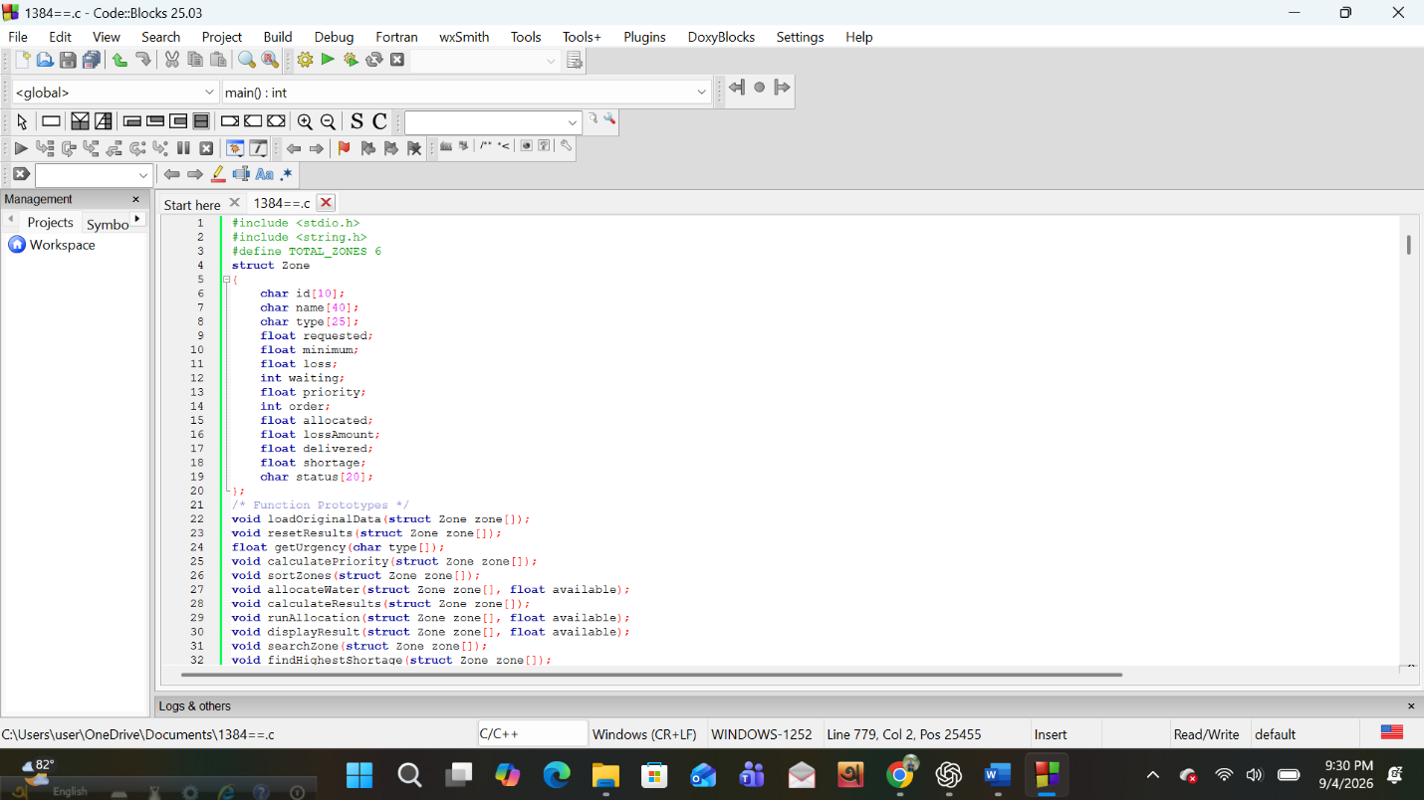

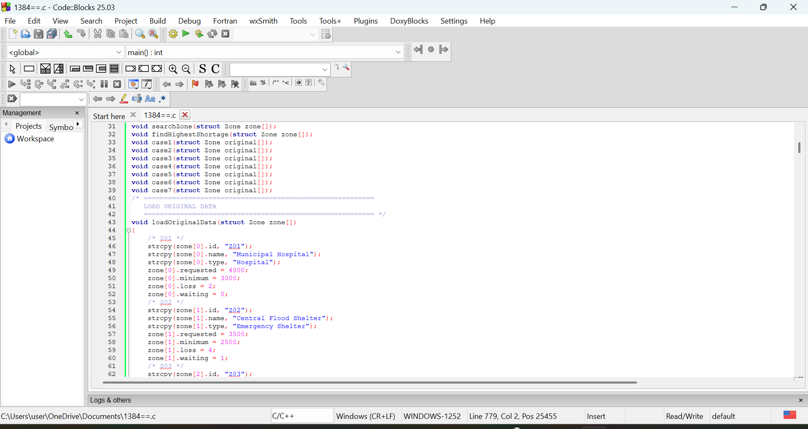

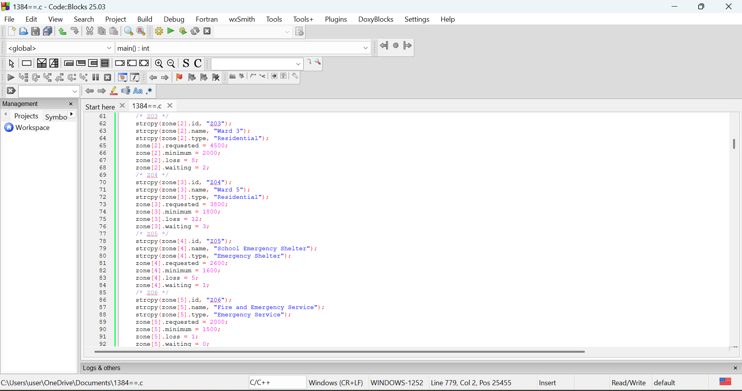

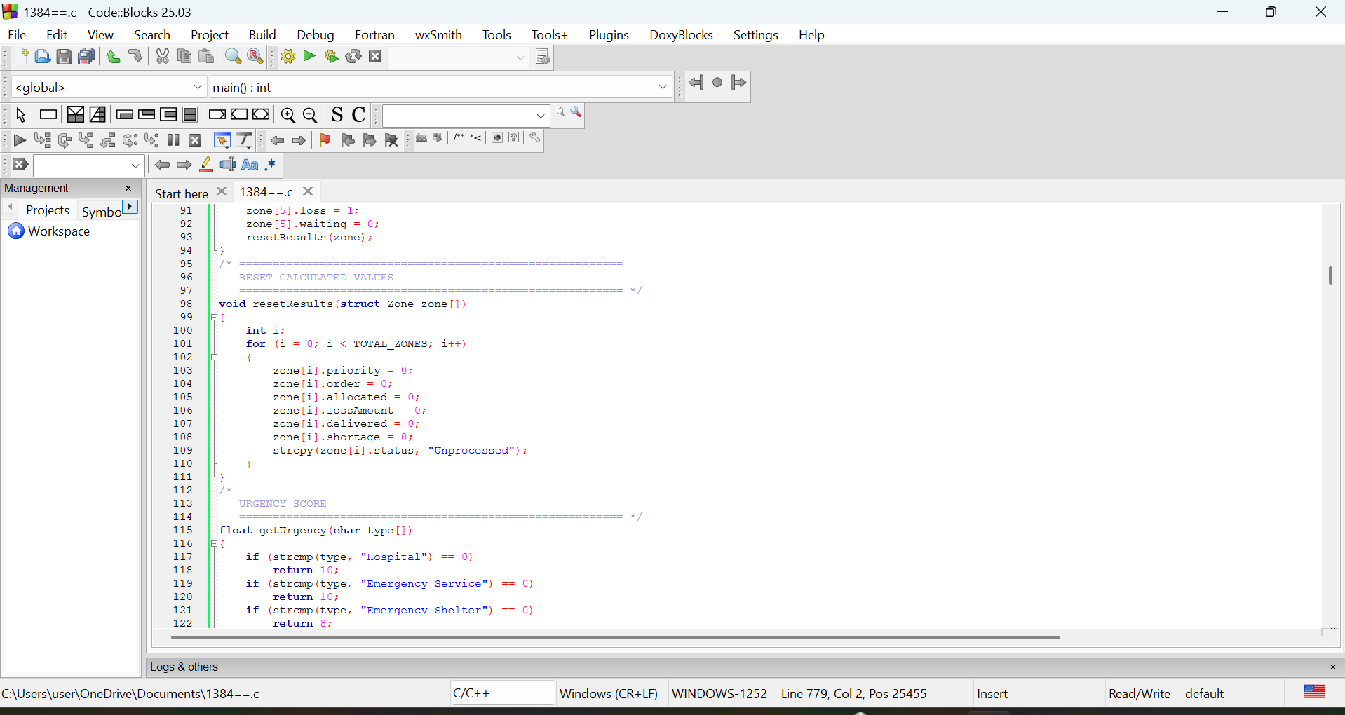

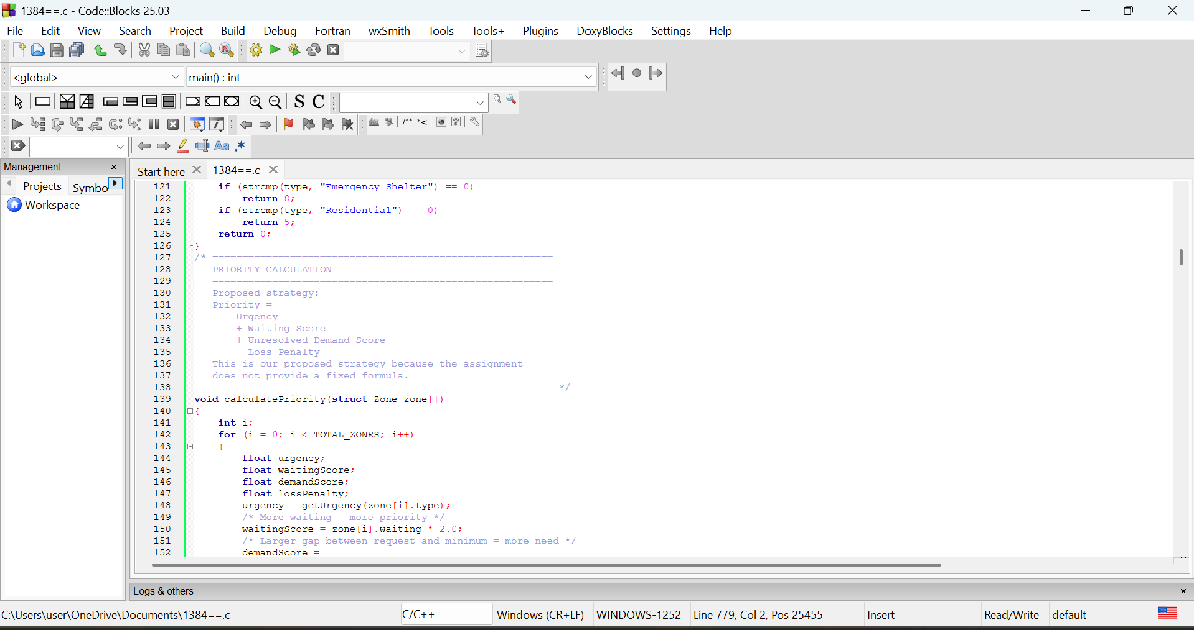

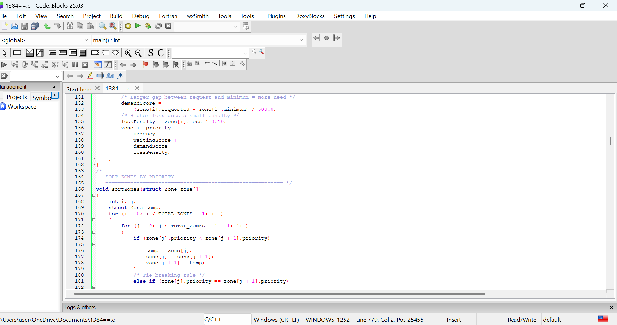

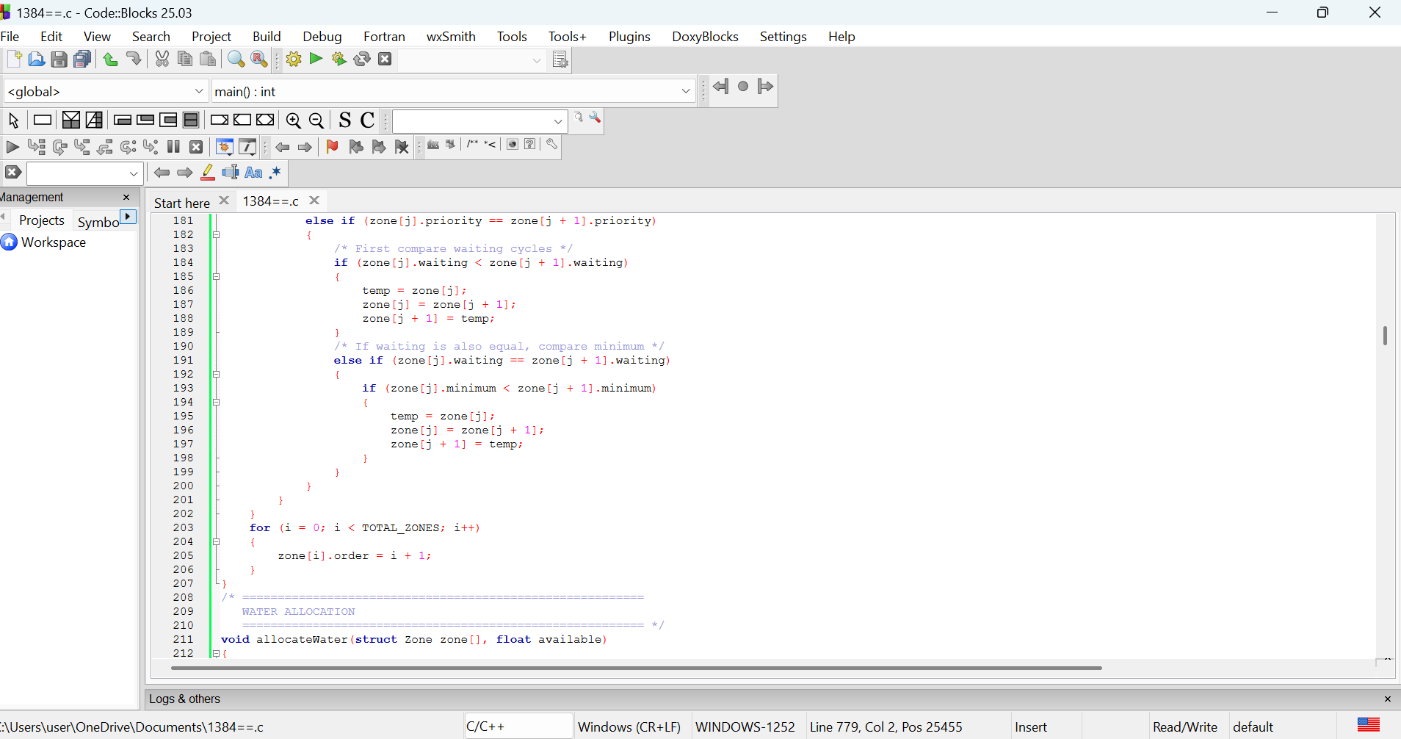

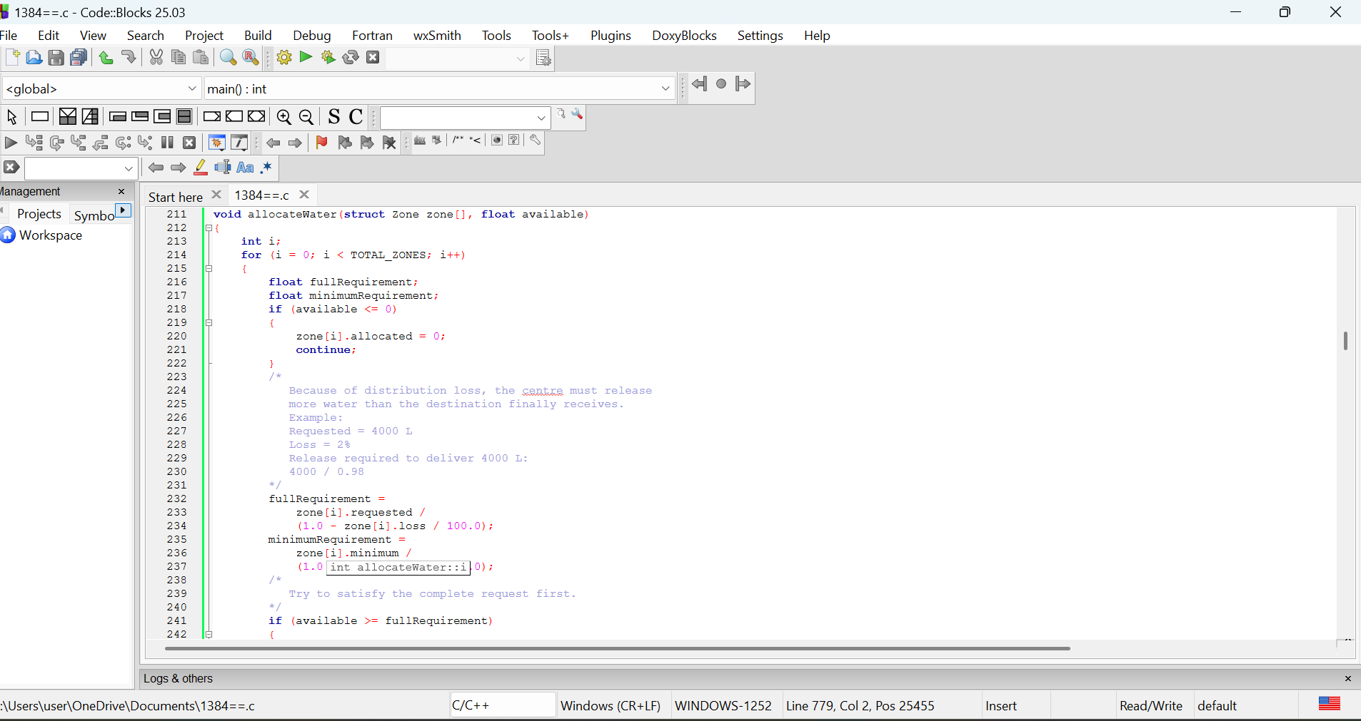

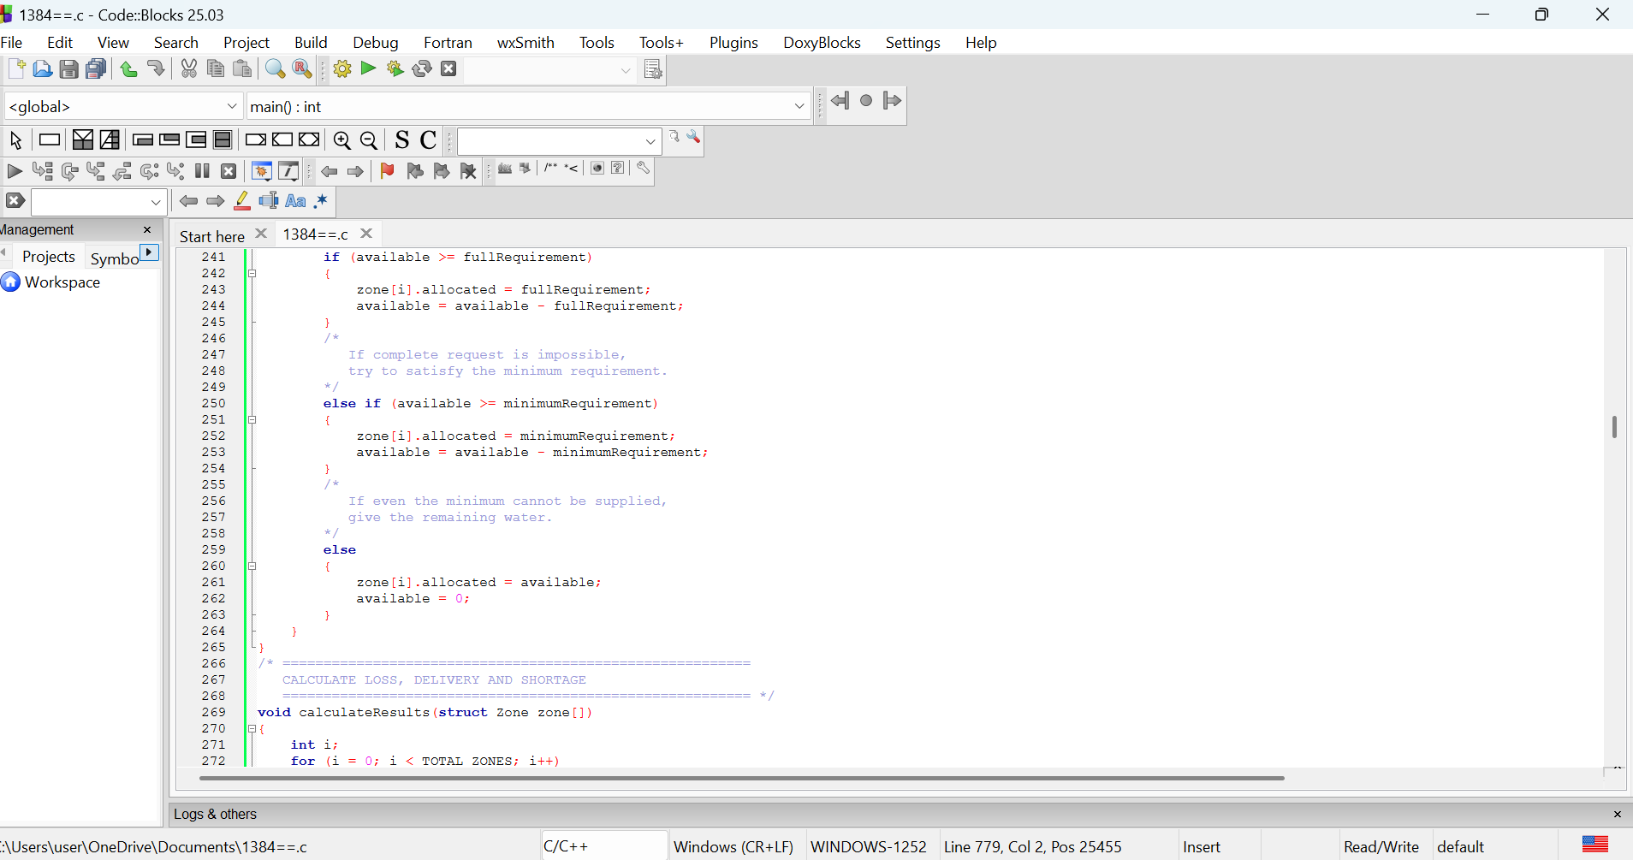

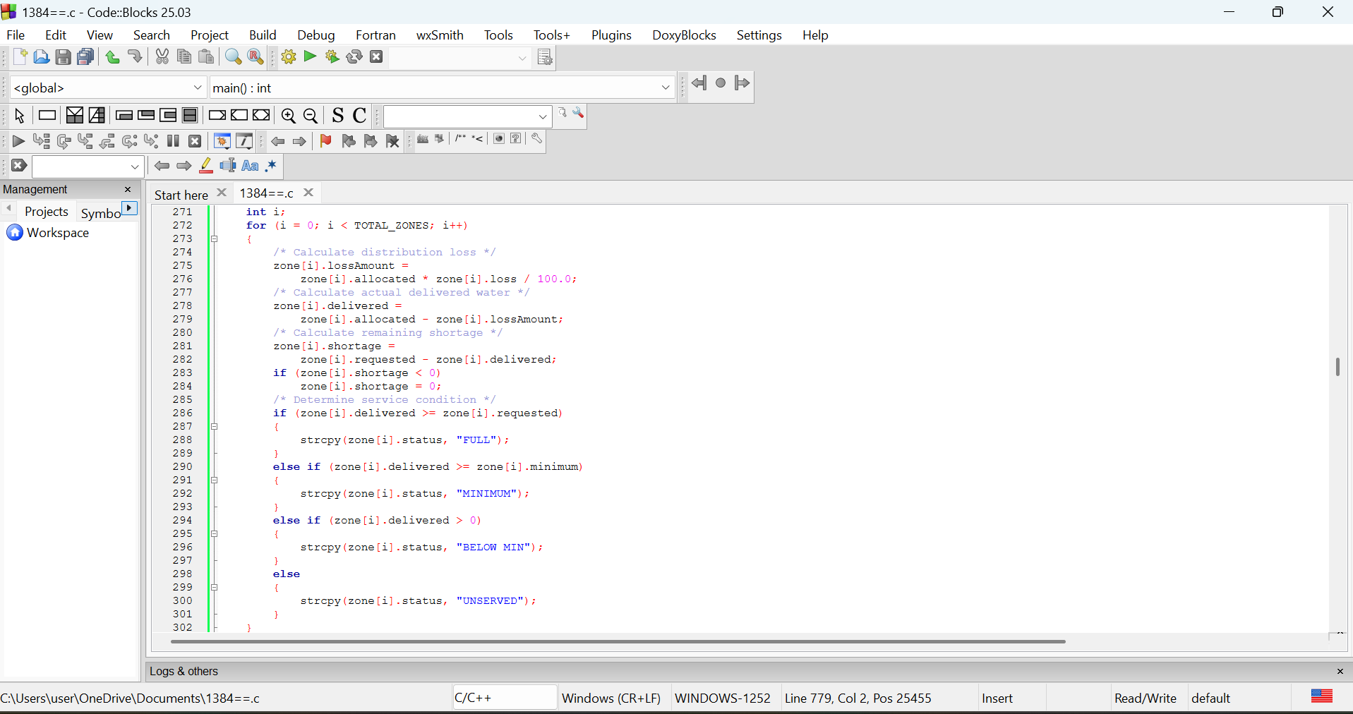

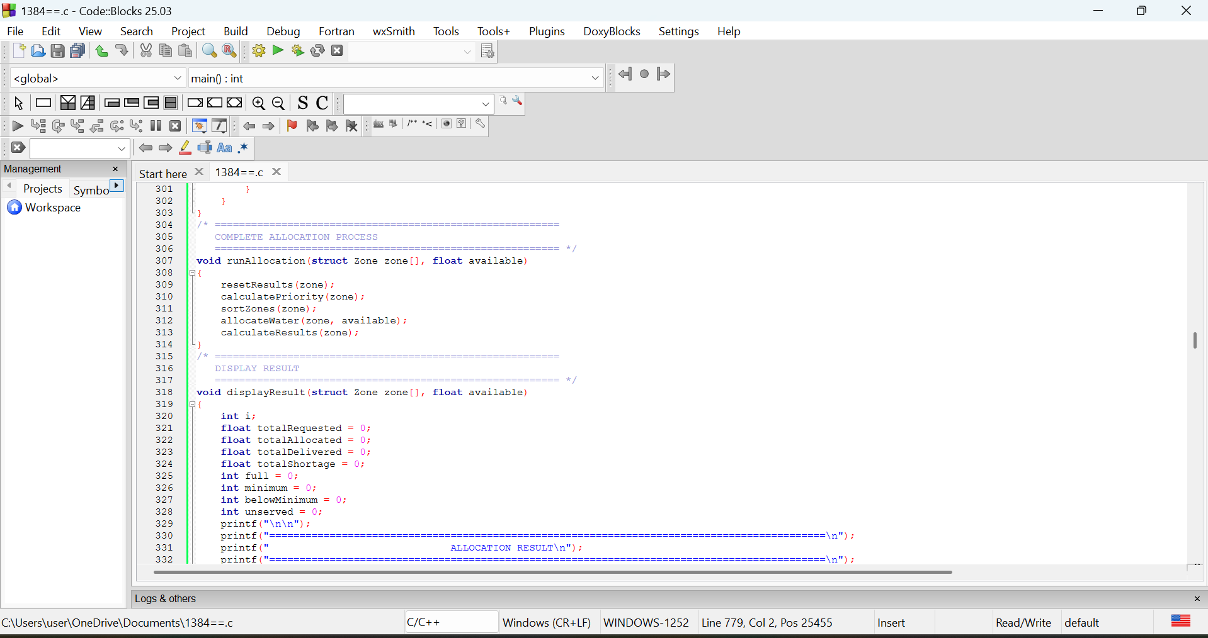

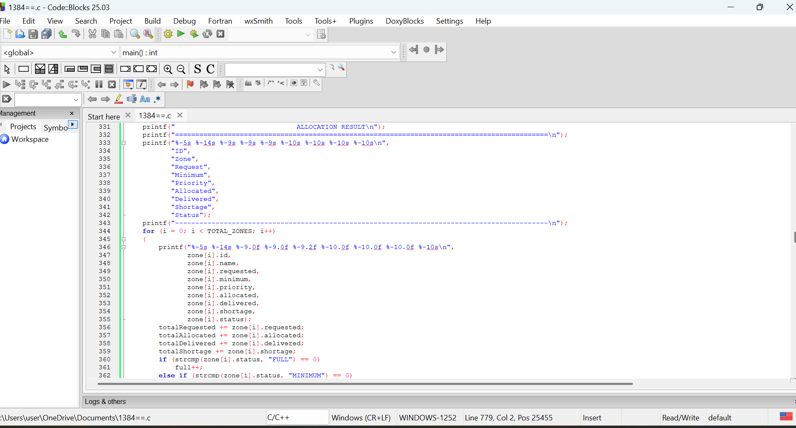

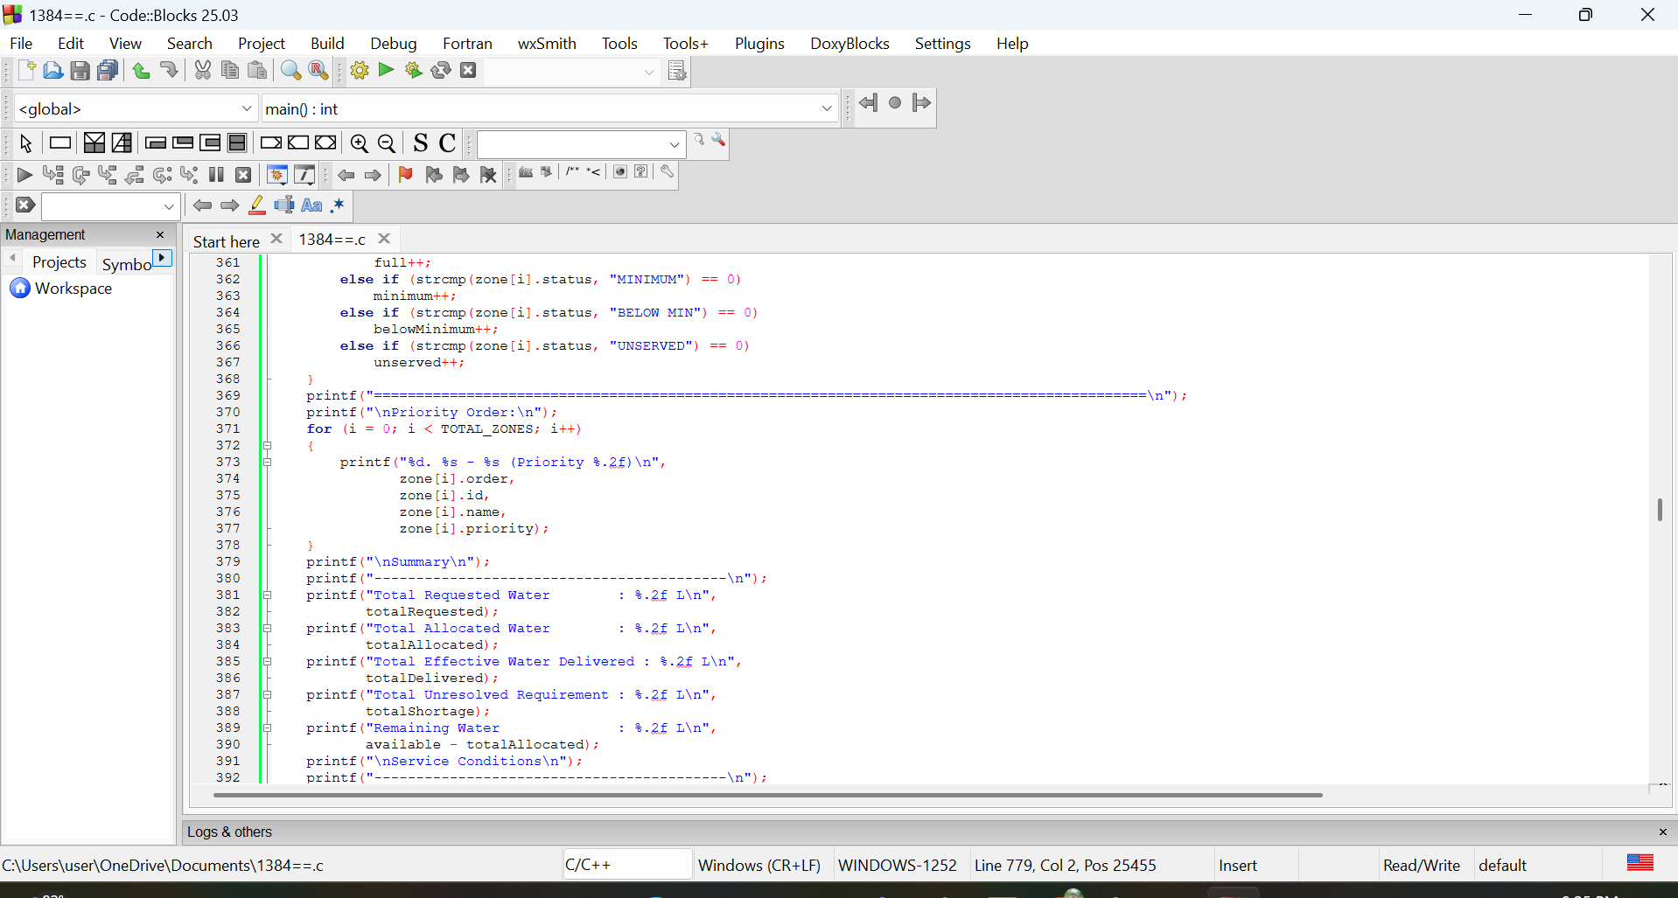

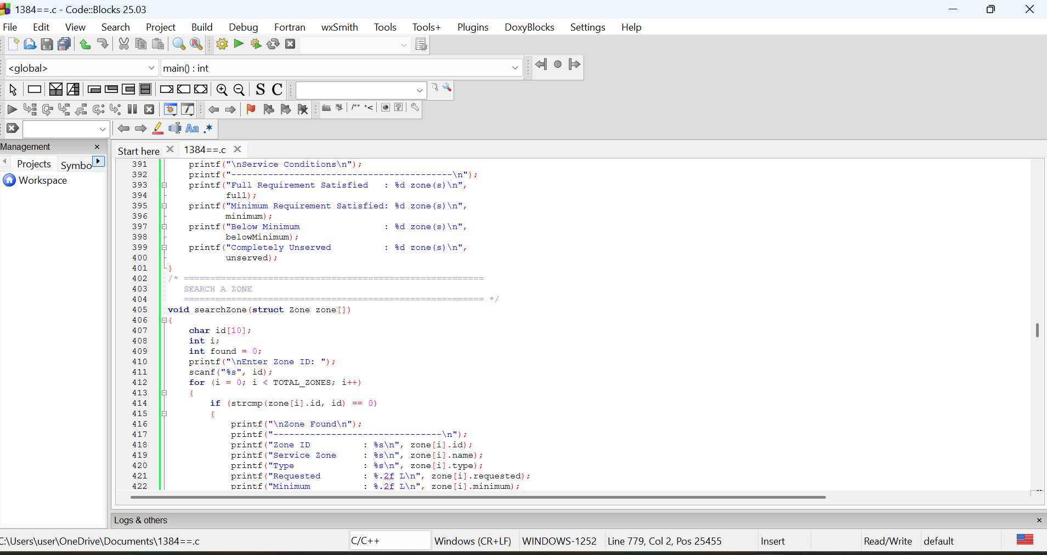

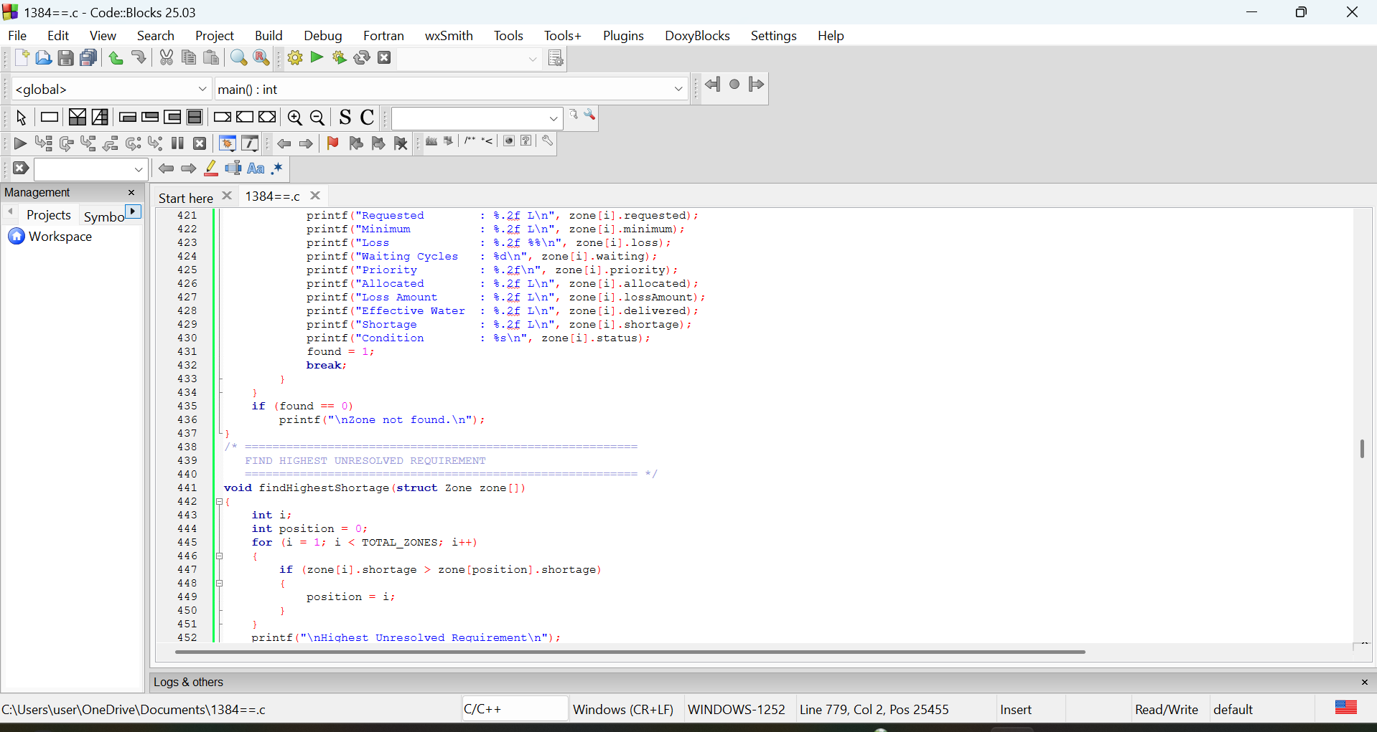

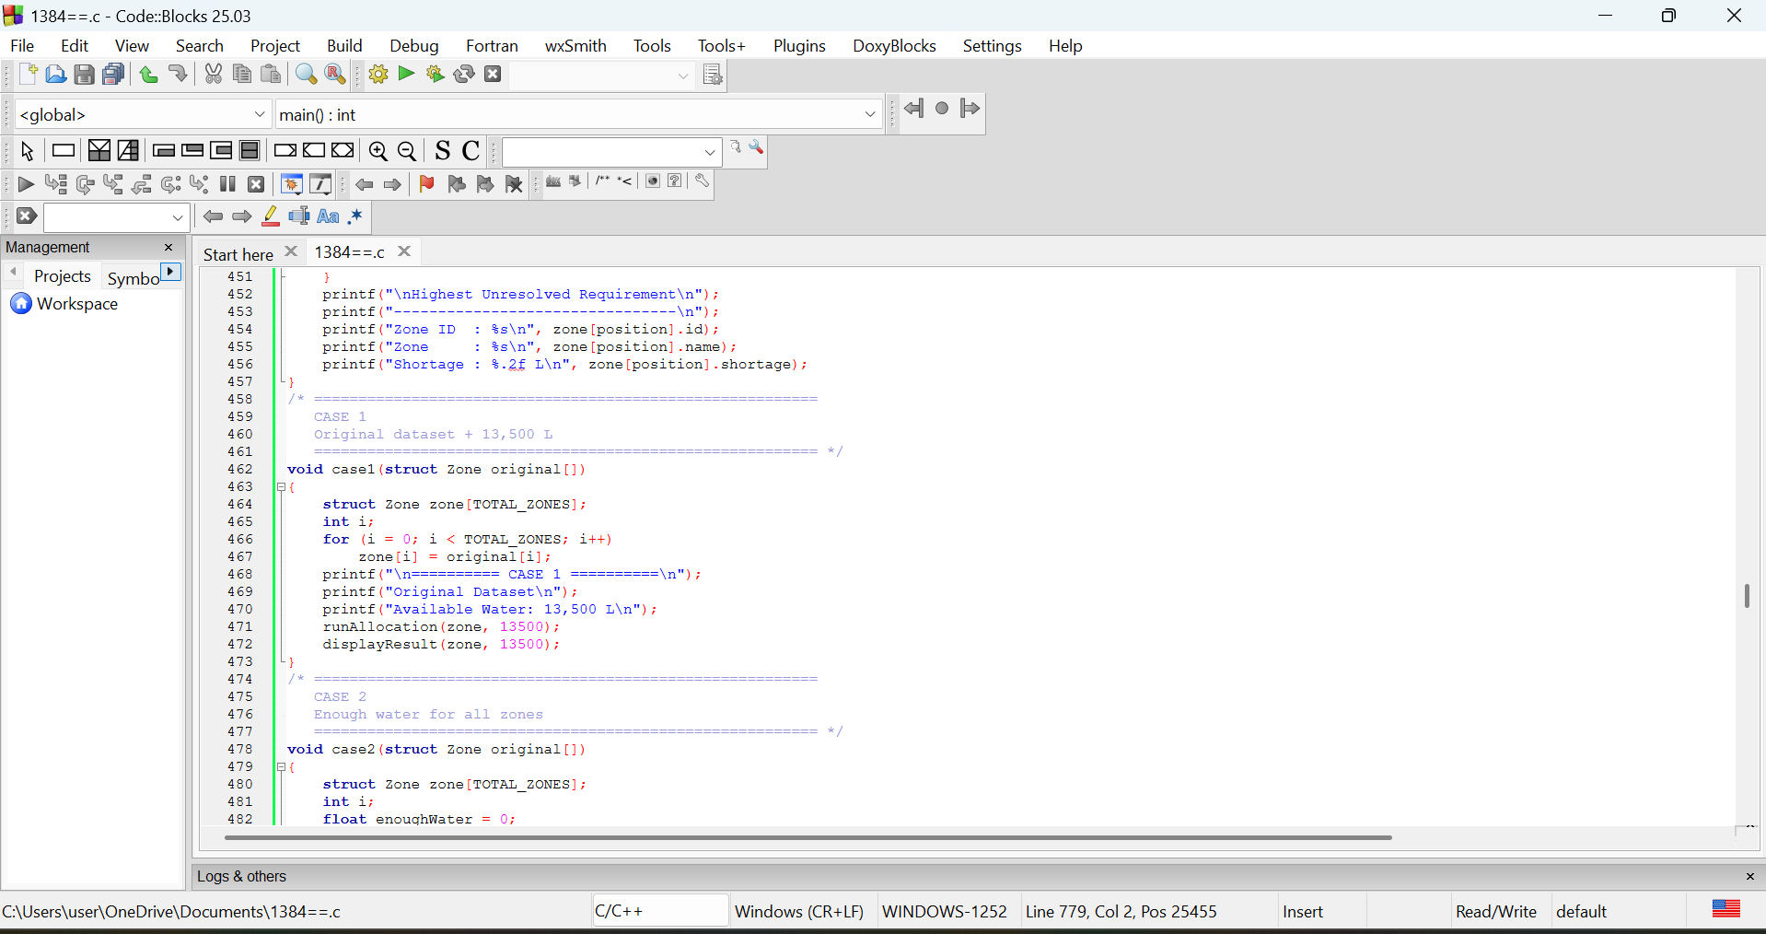

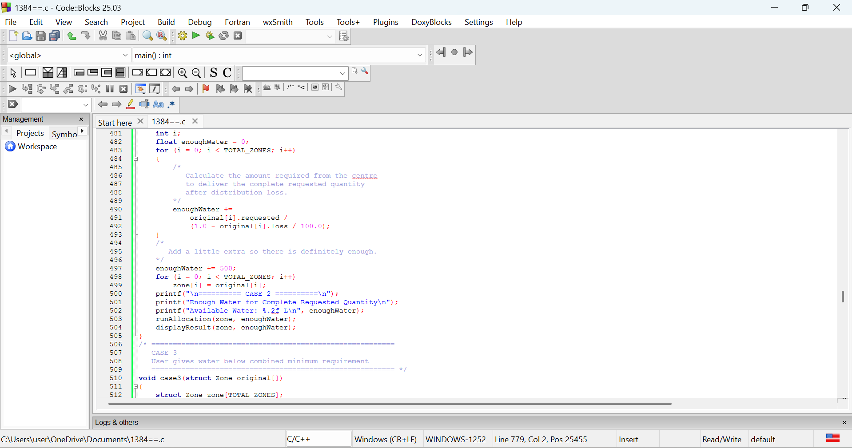

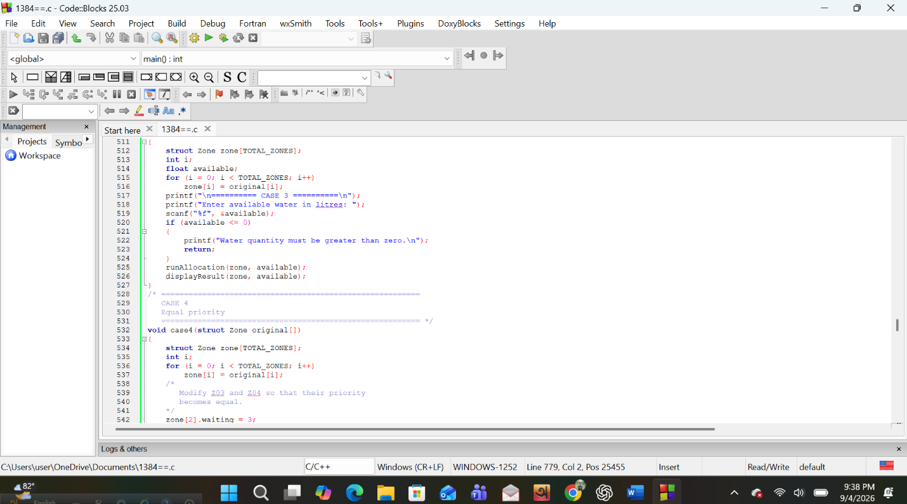

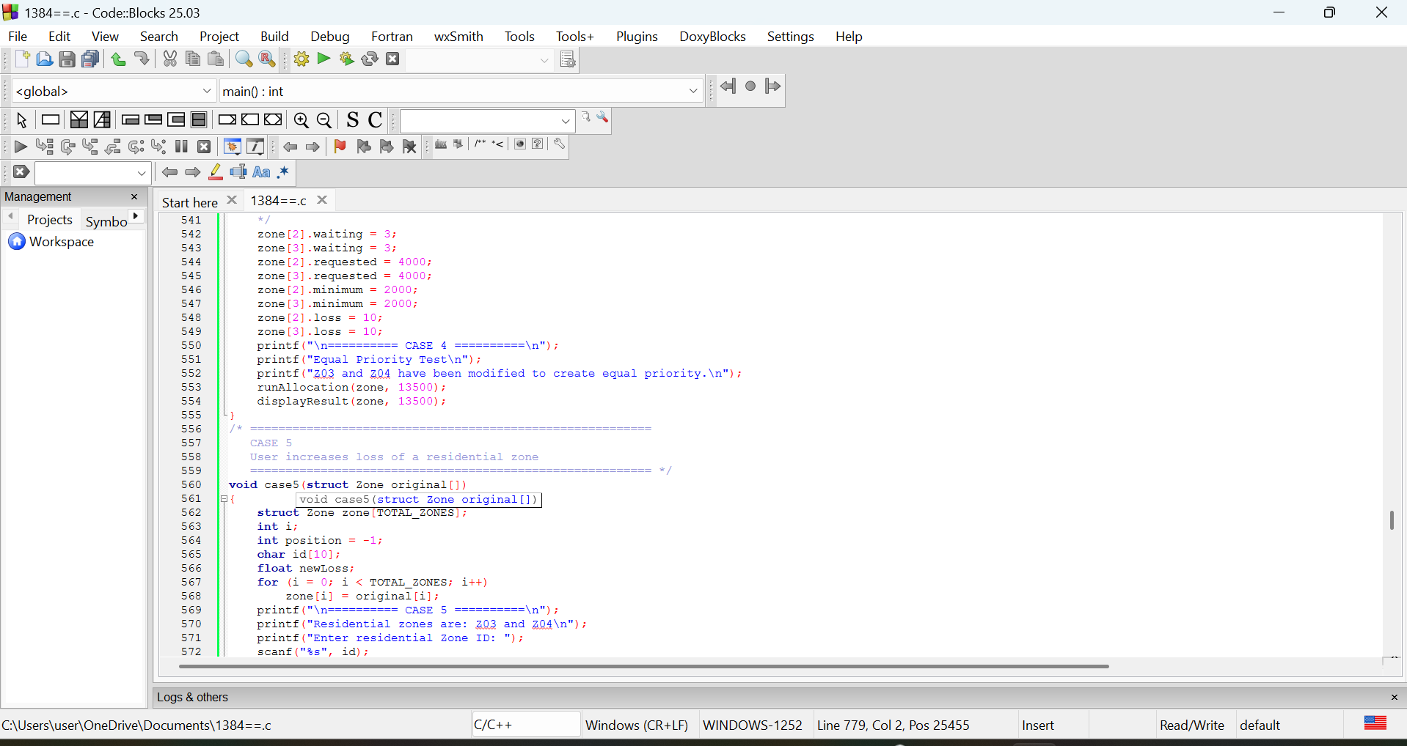

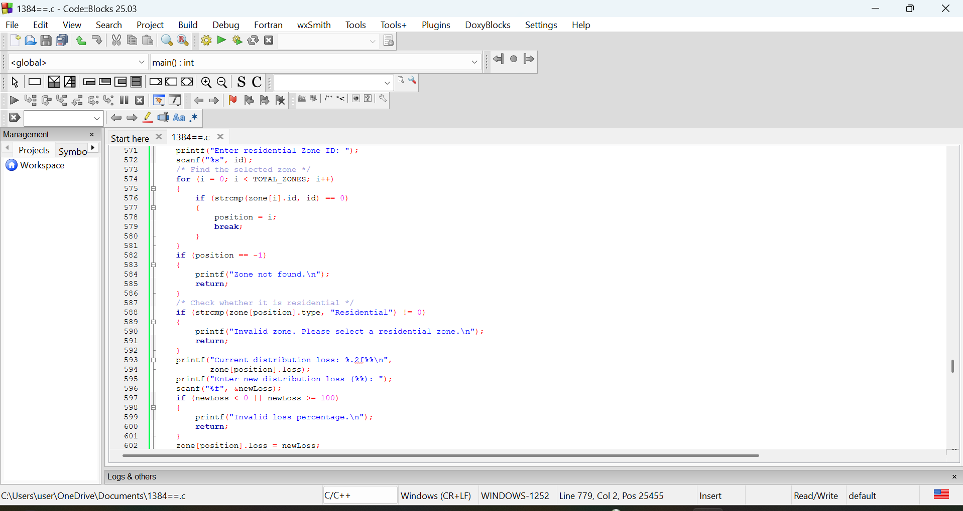

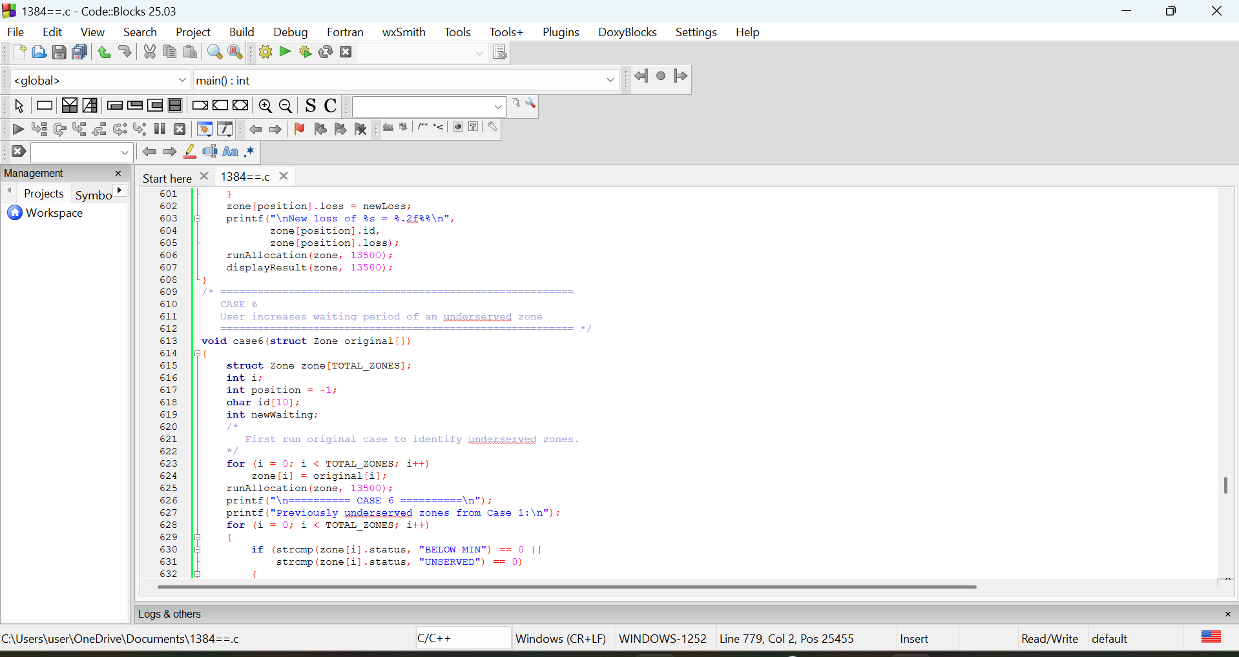

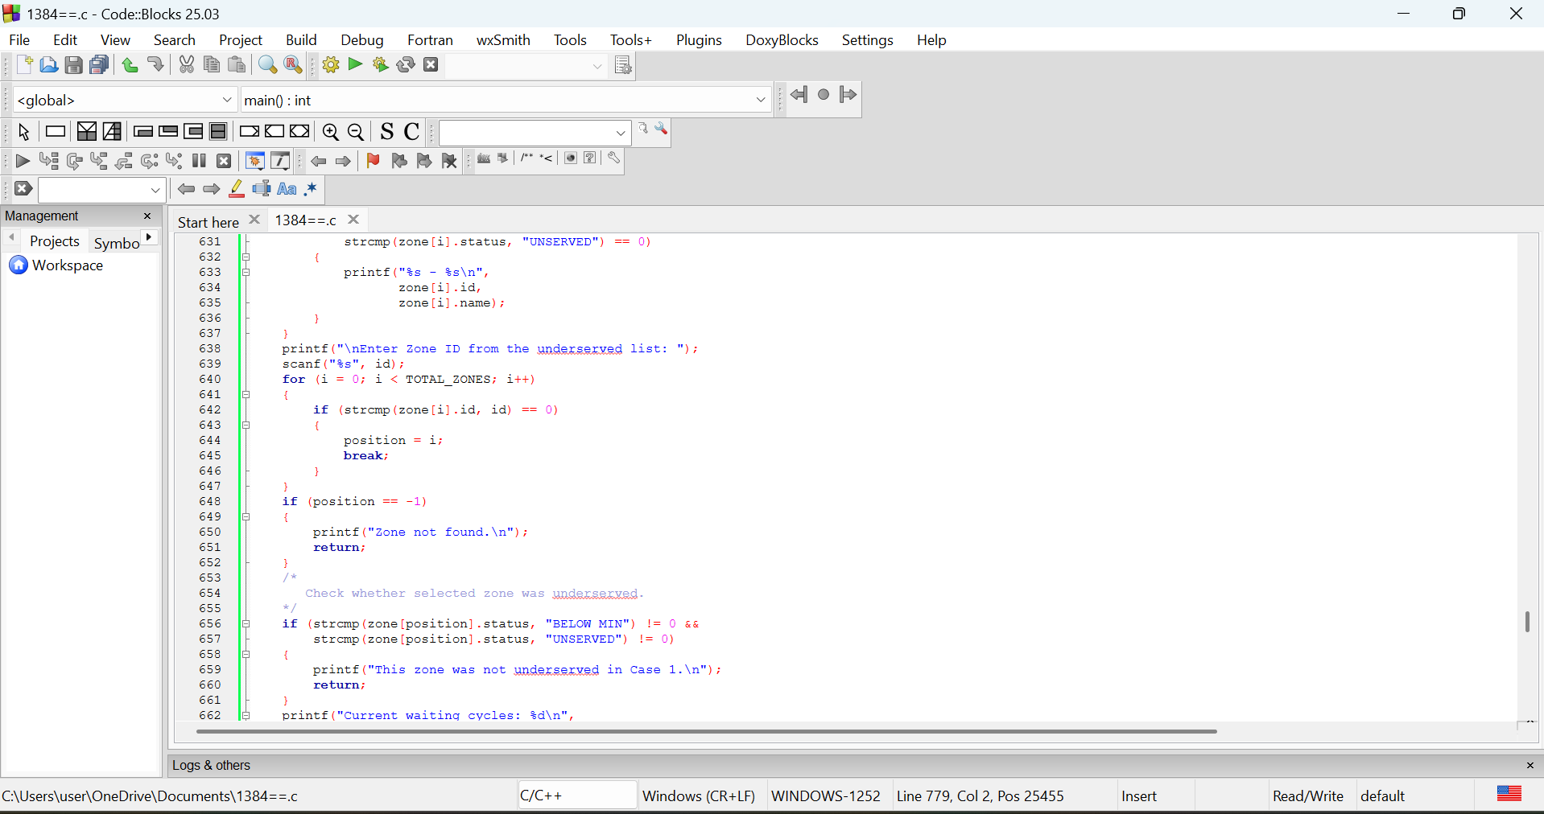

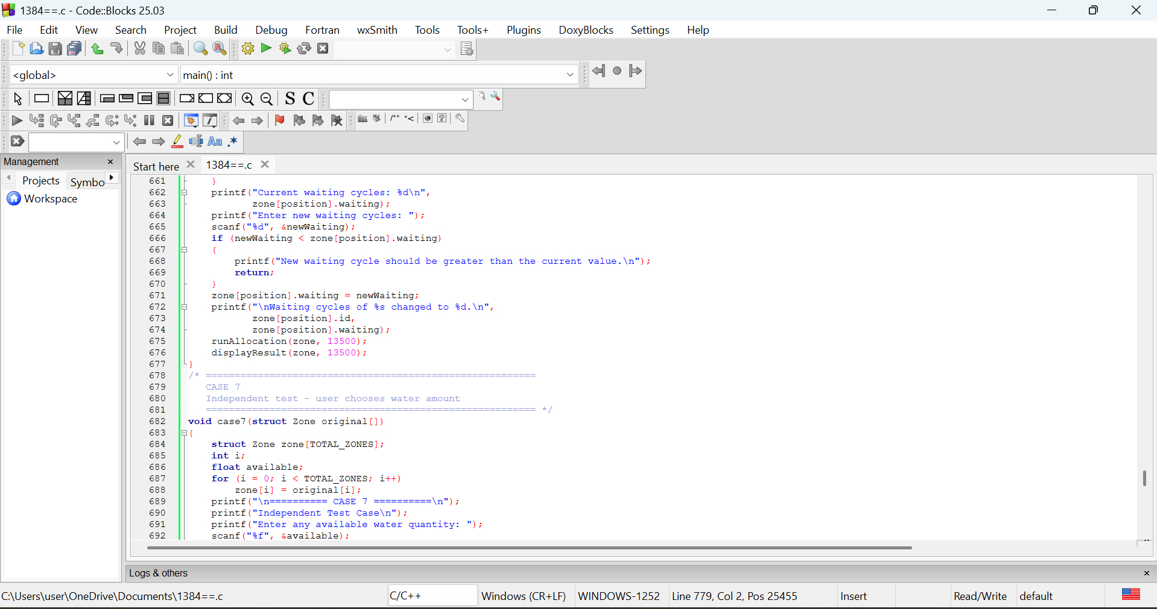

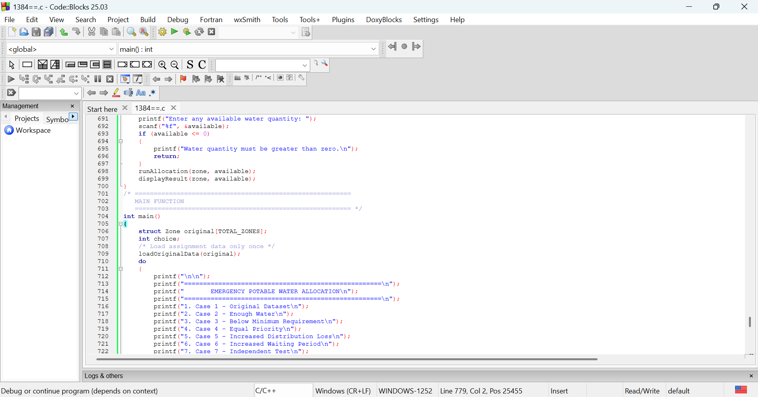

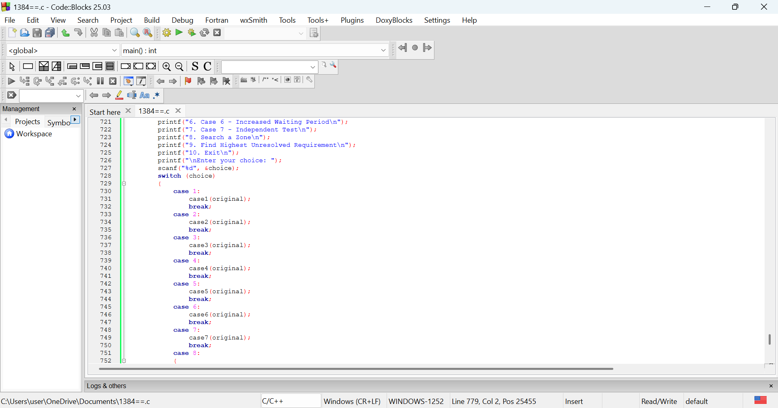

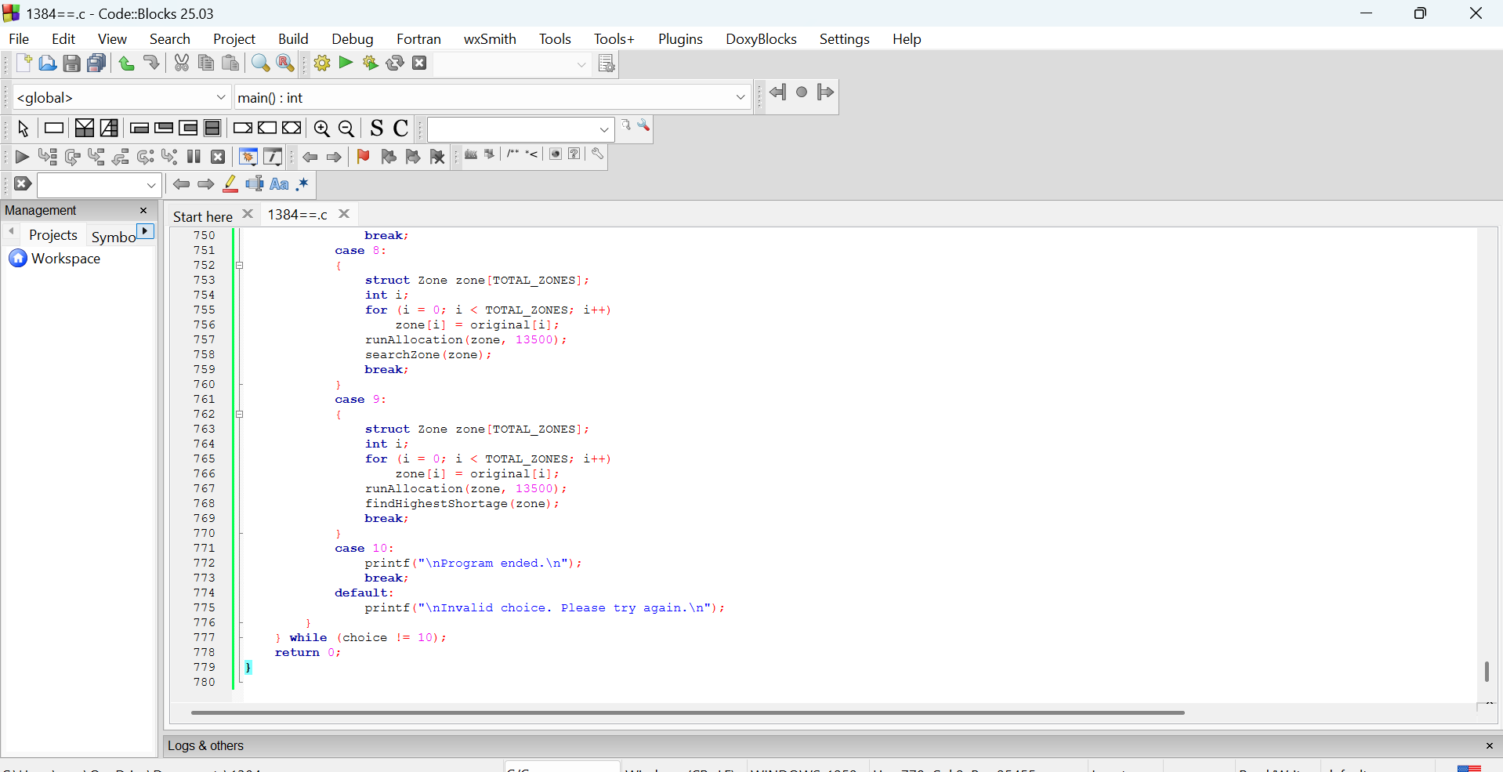

6. Testing and Validation

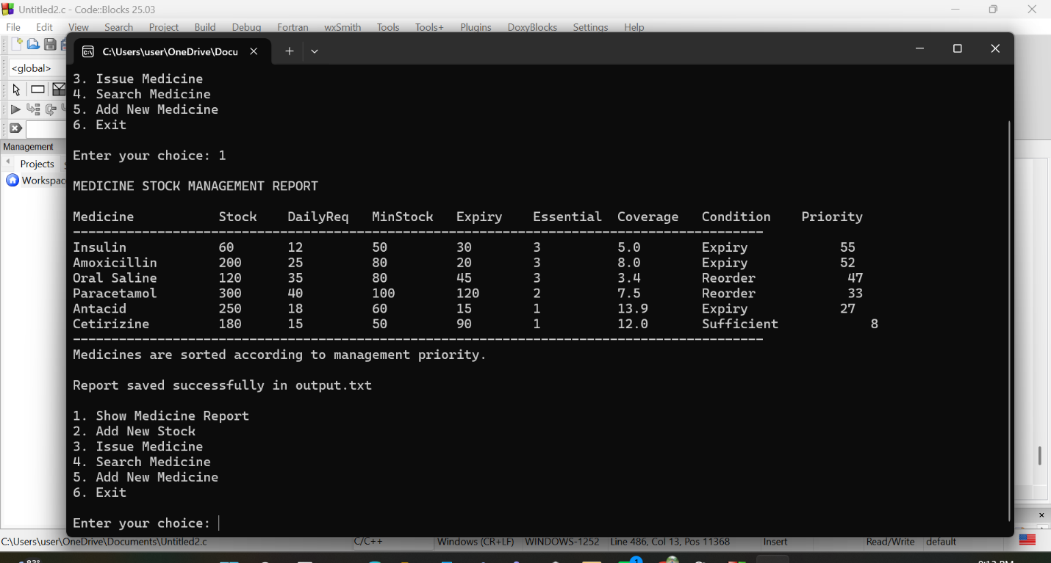

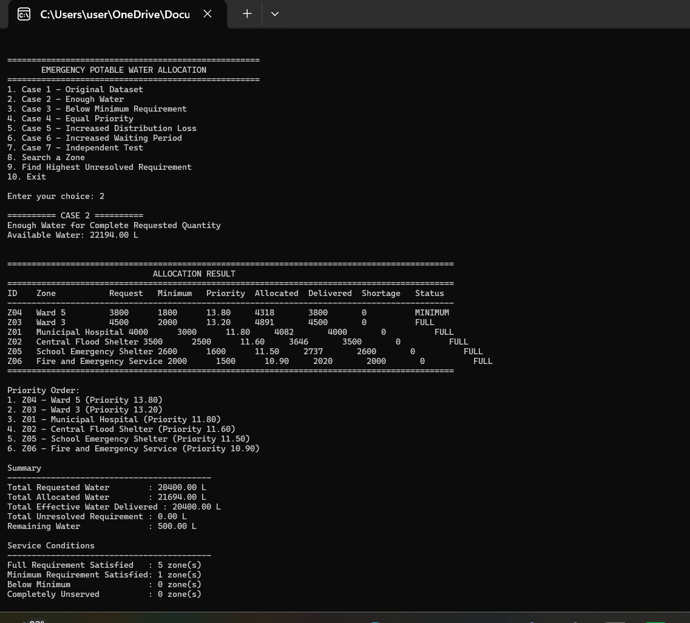

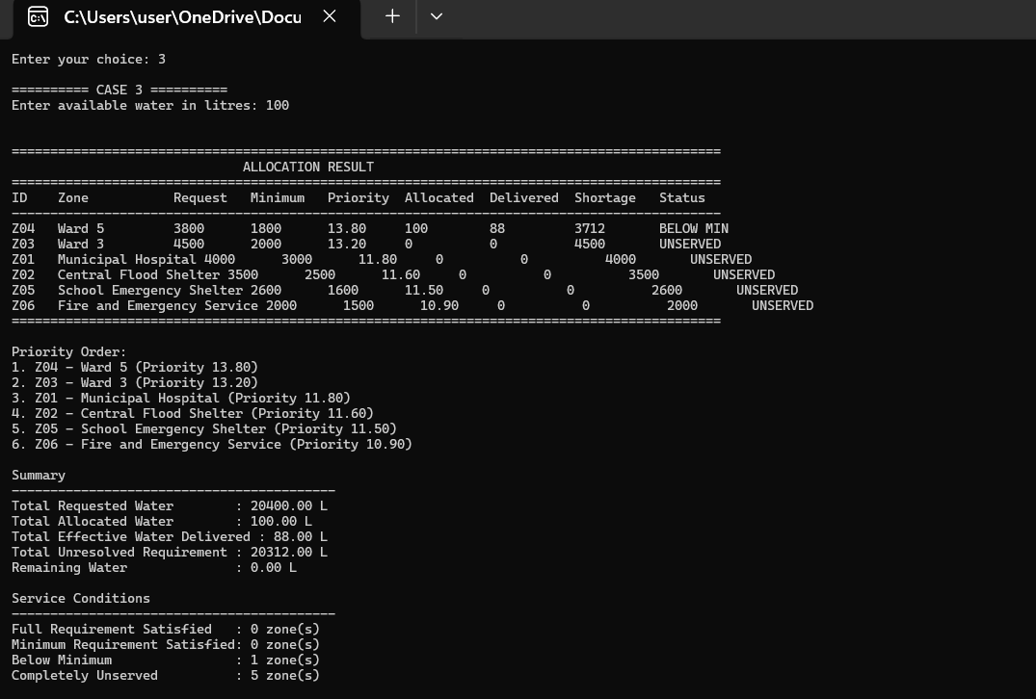

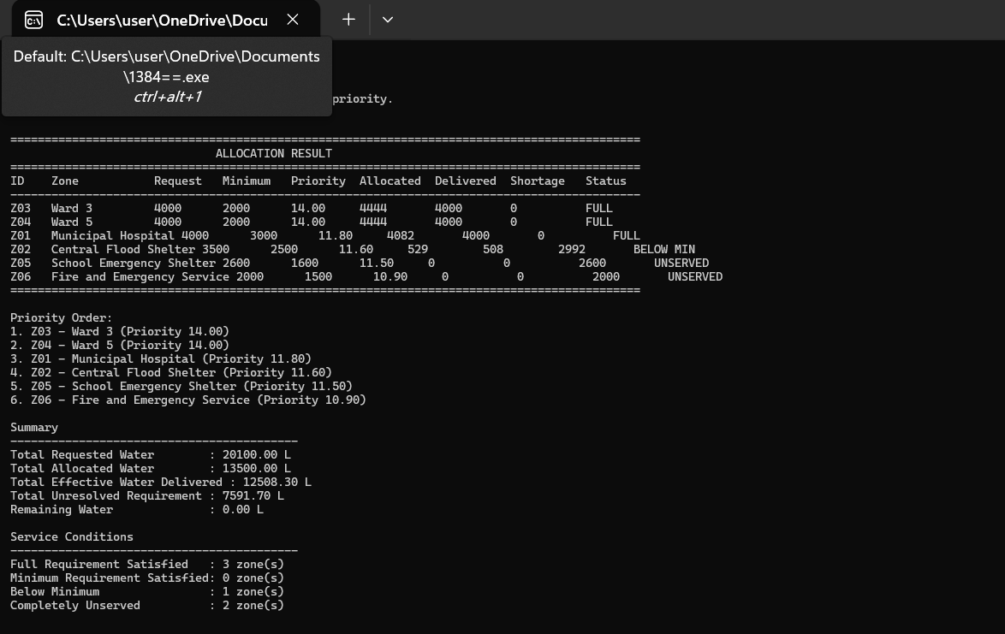

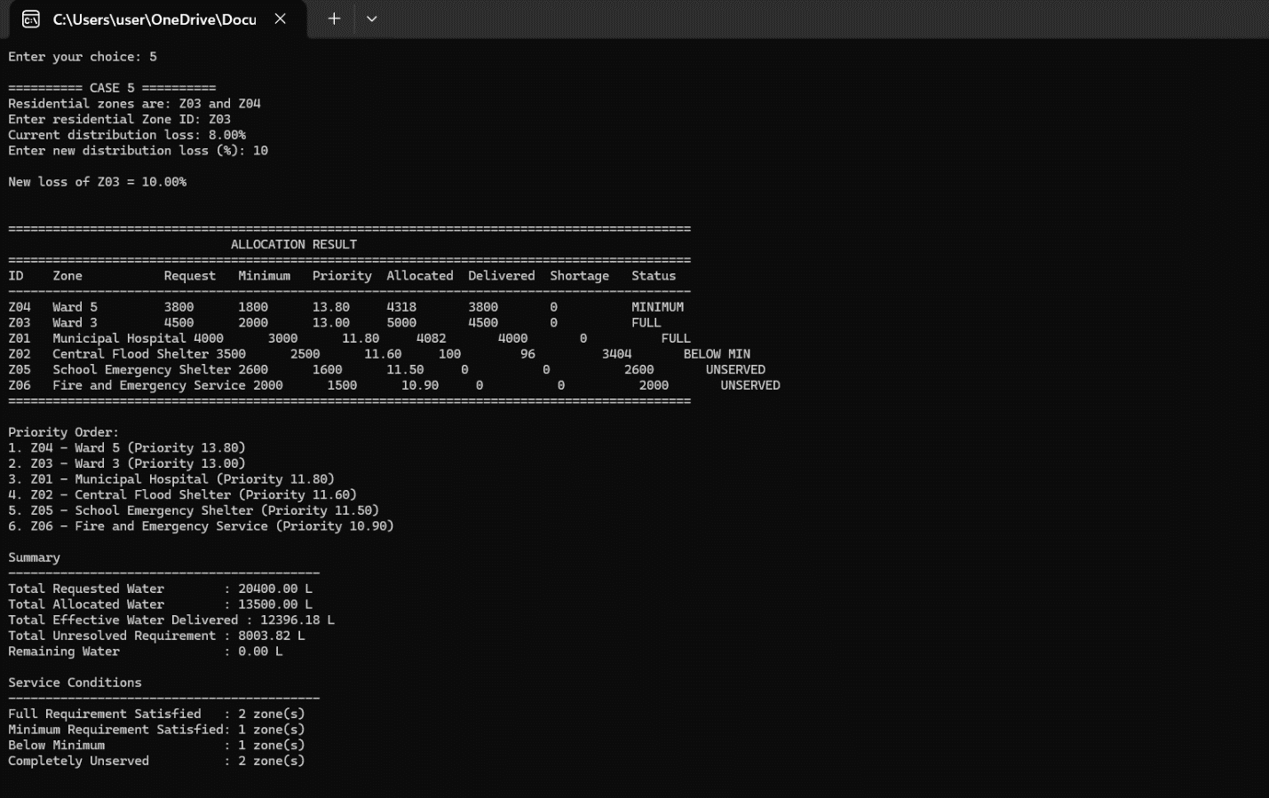

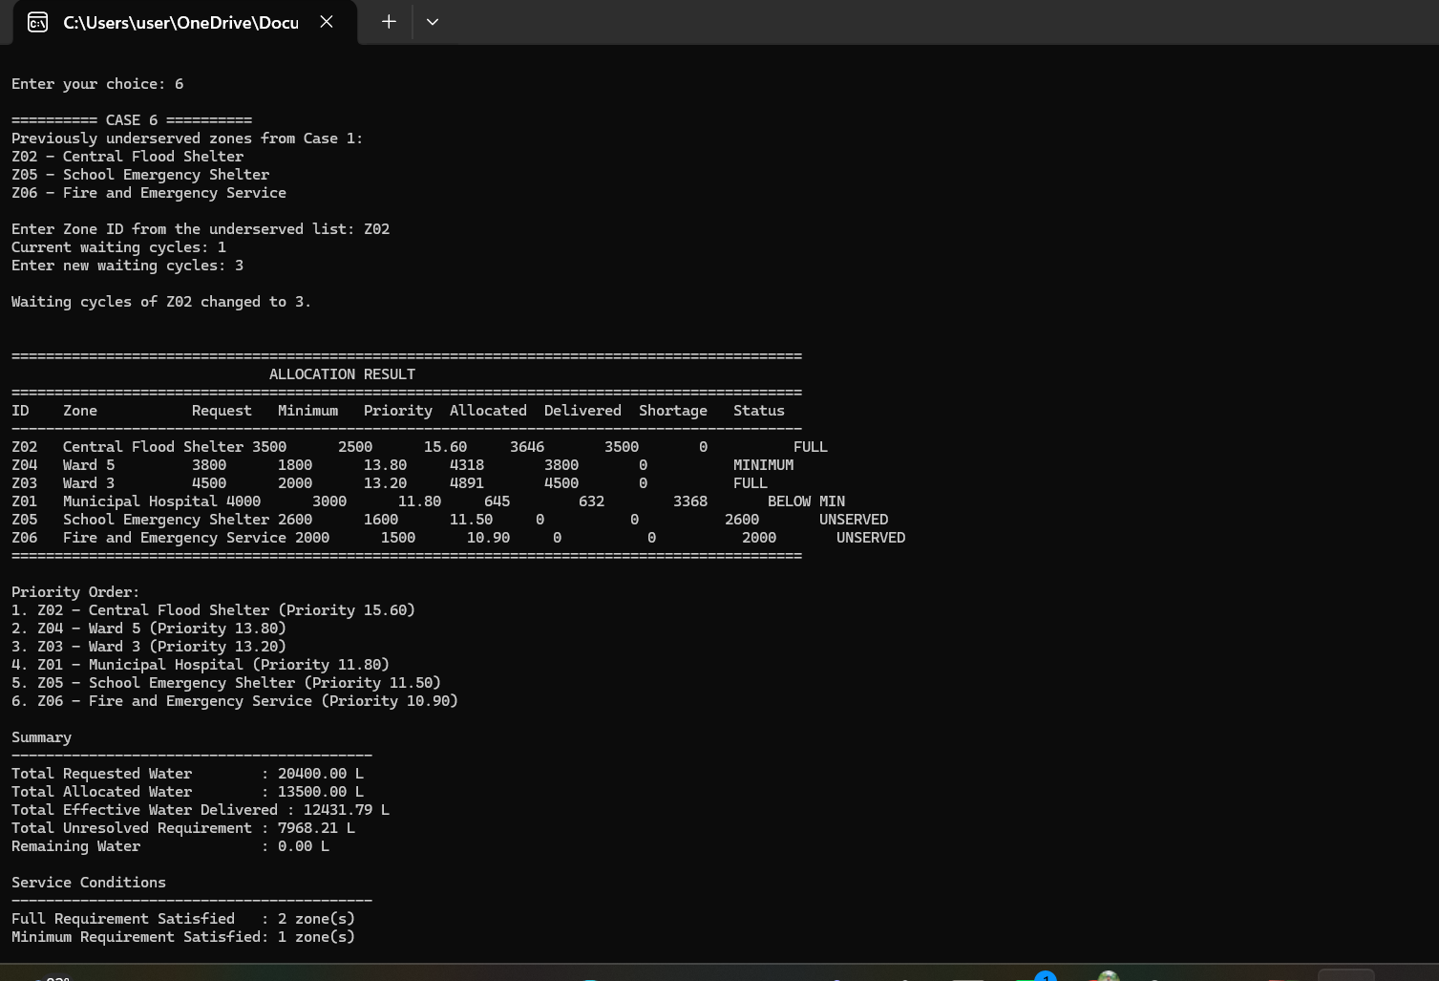

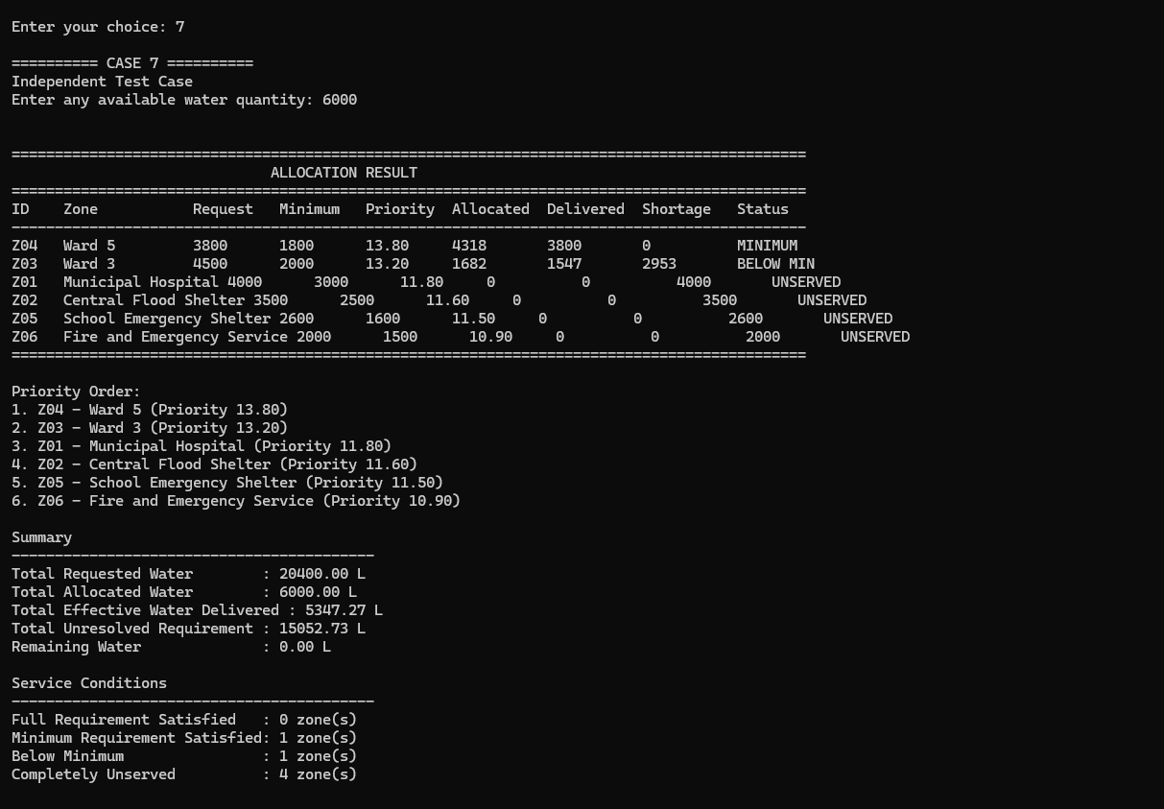

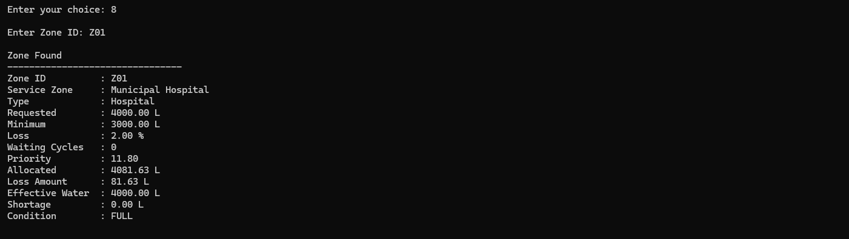

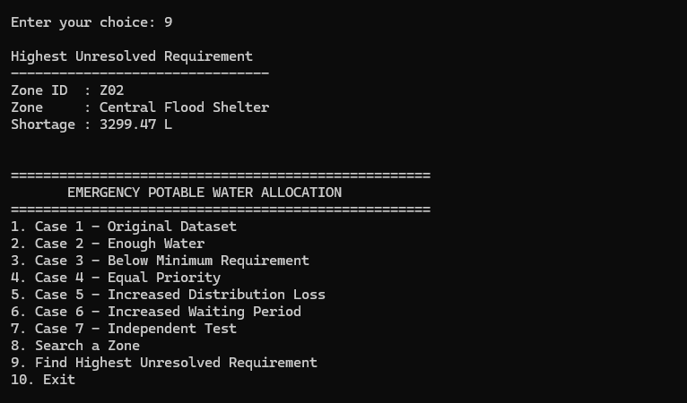

7. Limitations
The proposed solution rests on a number of assumptions and carries corresponding limitations that should be understood when interpreting its output.
- The distribution-loss percentage recorded for a zone is treated as a fixed characteristic of its supply route for the current cycle; the program does not model losses that vary with the quantity released, with weather conditions, or with the time elapsed during distribution.
- The previous waiting cycles figure is treated as an externally supplied count reflecting the zone's history prior to the current cycle; the program does not itself track or accumulate waiting cycles across multiple runs unless it is extended to persist this information between executions.
- The priority-scoring weights assigned to zone-type criticality, minimum-requirement urgency and waiting cycles represent one reasonable, explained approach among several that could satisfy the assignment brief, which explicitly permits students to adopt a different, justified strategy; another reasonable strategy would be expected to produce broadly similar, though not necessarily identical, allocations on the supplied dataset.
- The two-phase allocation assumes that guaranteeing every zone's minimum requirement before extending any zone toward its full request is the appropriate ordering of objectives; a municipality that instead wished to priorities fully satisfying its most critical zones first, even at the expense of the minimum requirement of lower-priority zones, would need a different allocation structure.
- The dataset size assumed for demonstration is small, and the sorting technique selected in Section 5 is chosen accordingly; a much larger number of service zones would warrant reconsideration of the selected technique.

8. Conclusion
This assignment required the design of a structured, C-language solution to an emergency resource-allocation problem in which the total demand for potable water exceeds the available supply, and in which the zones requesting water differ in criticality, prior waiting history and distribution efficiency. The proposed solution assigns every zone a priority score that combines its type criticality, its minimum-requirement urgency and its previous waiting cycles, orders the zones accordingly, and allocates the available water in two phases that first guarantee, as far as the available water permits, the minimum requirement of every zone and then extend the remaining water toward the full requested quantity of each zone in priority order. Distribution loss is applied consistently when converting a target delivered quantity into the corresponding release quantity, rather than being allowed to distort the priority ranking itself, addressing the specific concern raised in the assignment brief regarding the interaction between distribution efficiency and social requirement. The design keeps every derived value attached to the zone record it describes, computes each derived value once, and is intended to remain correct when the supplied requested quantities, minimum requirements, loss percentages, waiting cycles or available quantity are changed. Sections 6 and 7 of this report, concerning the implementation and its testing, are to be completed separately alongside the submitted source code and test evidence.

9. References
[1] Course materials and assignment brief, "Assignment on Structured Programming LAB — Emergency Potable Water Allocation for a Flood-Affected Municipality," CSC 1384 Structured Programming LAB, Summer 2026.

